Deeper Dive into vH4 (quarto)

METHODLOGY
Data was prepared as described in the separate report, “Source Data, Cleaning, and Preparation.” This model trained on the years 2006 to 2023 and tested on data from the year 2024.
A predictive model was trained with the package “xgboost.”
A value for math grade was predicted, and evaluated with the root mean square error, mean absolute error, and r-squared values.
These values were also combined into a binary categorization (“high”/“low” or “success”/“fail” or “on track”/“at risk”) using various thresholds or cut-offs. An optimum threshold or cut-off was discovered with the highest Kappa value.

DISCUSSION
The model attempts to take information available at the time of admittance, skip over course selection as a black box process, ignore concurrent data such as class details (time of morning or capacity), and predict grade performance for first-time freshmen at the end of their initial math course. This comparison of the model with the timeline of the actual student experience is shown in Figure 1.
With this minimalist data set, the model could predict grades in initial math courses for first-time freshmen with an R-squared value of 0.28, root mean square error of 1.01, and mean absolute error of 0.8.
The variables most important to the model were the high school GPA, the ACT math test scores, and their derivative z-scores and combined z-score distance to the qualifications of the prior year’s median successful student.
This aligns with a theory of performance (Figure 11) where a student’s math ability (as measured by the ACT math test scores) and a student’s ‘study ability’ (as measured by their high school GPA) are strong predictors of performance. However, the model is not completely determinative – the pre-University data doesn’t define the grade received – leaving room for individual motivation, effort, and the influence of the concurrent situation (such as the number of credits taken that semester). No student is guaranteed an ‘A’, as many students who are predicted to score well do poorly (and vice versa.)
Given the sparsity of the data, the model tended to predict in the middle of the range, putting 47% of the students between a grade of 2.7 and 3.7, while some 39% of students in 2024 actually received an ‘A’. Several comparisons of the predicted and actual grades are presented as scatter plots or box plots (Figure 2), density plots (Figure 3), heat maps (Figure 4), confusion matrices (Figure 6, Figure 9), and histograms (Figure 7, Figure 8).
An optimum binary threshold was found at a predicted grade of 2.4, with a Kappa value of 0.41. Students predicted to have a grade less than 2.4 are a high-risk group of students. 29% of these 507 students actually did fail, or 76% of the total of students who failed. (76% recall and 29% precision).
This compares to the risk of students predicted to have a grade more than 2.4. Only 47 of these 1195 students failed, or 4%.
Only a handful of students were precisely predicted fail their initial math course – eight students were predicted to receive a grade less than 0.9, and six of these students actually received a grade less than 0.9. These students might be considered admissions mistakes, as they predictably failed. However, out of 1,759 students, this doesn’t seem to indicate a large problem with admissions standards.

CONCLUSIONS
The model could predict grades in initial math courses for first-time freshmen with an R-squared value of 0.28, root mean square error of 1.01, and mean absolute error of 0.8. The variables most important to the model were the high school GPA, the ACT math test scores, and their derivative z-scores and combined distance.
The model had optimum performance in separating an at-risk population and a successful population at a predicted grade threshold of 2.4 (between a C-plus and a B-minus.) Accuracy at this cut-off had a Kappa value of 0.41.
At this cut-off, the actual failure metrics (grades less than a 1.7) were 76% recall and 29% precision, or roughly one-third of the identified “at risk” group actually failed and one out of twenty-five of the “successful” group actually failed.

POSSIBLE NEXT STEPS
Grade prediction accuracy should increase with the inclusion of concurrent data, such as:
- The number of credits taken
- Difficulty of concurrent classes
- Initial course grades on quizzes, homework, and initial tests
- Utilization of tutoring services
- Participation in study groups
The model might improve with an indicator that clusters similar classes (in terms of incoming qualifications) together. This could help differentiate many small courses by combining them.

RESULTS
Figure 1: Model compared to the timeline of actual student experience
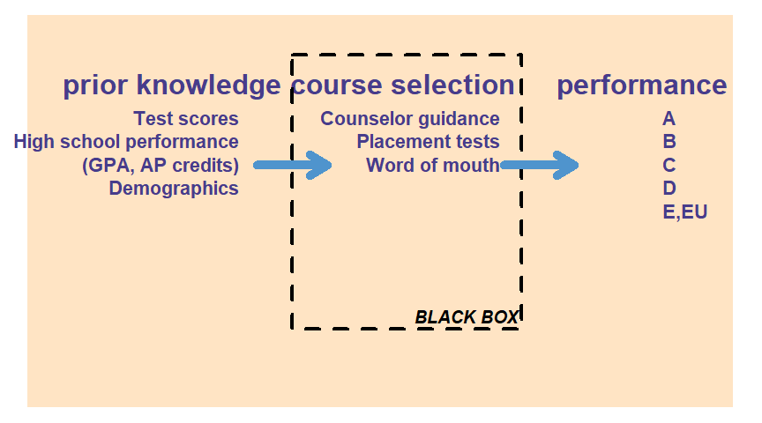
Table 1: Regression Results
 | Raw Metrics |  |  | Normalized Metrics
 | RMSE | MAE | R2 | NRMSE_range | NMAE_range | NRMSE_sd | NMAE_sd
GRADEGPA | 1.01 | 0.8 | 0.28 | 0.25 | 0.2 | 0.89 | 0.7
Figure 2: These plots show what the correct prediction value would be with a red line.
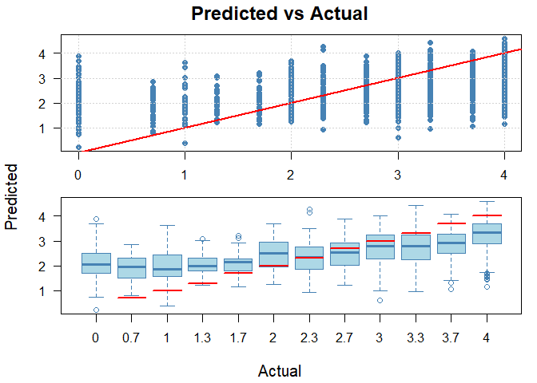
Figure 3: The model tends to predict towards the center, while most students earn an ‘A’.
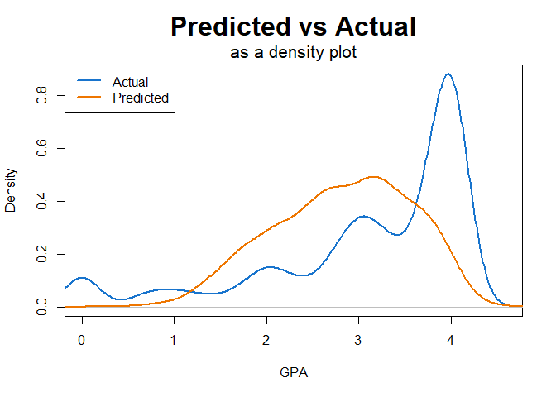
Figure 4: The heatmap shows grade expectations increase with ACT Math and high school GPA.
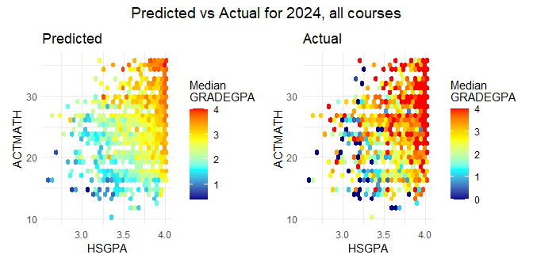

Selection of model optimum binary cut-off or threshold
The model has the highest accuracy in separating into high/low (or succeed/at-risk) populations at a predicted grade of 2.4, between an actual grade of C-plus (2.3) and B-minus (2.7).
Figure 5: Selection of model optimum cut-off
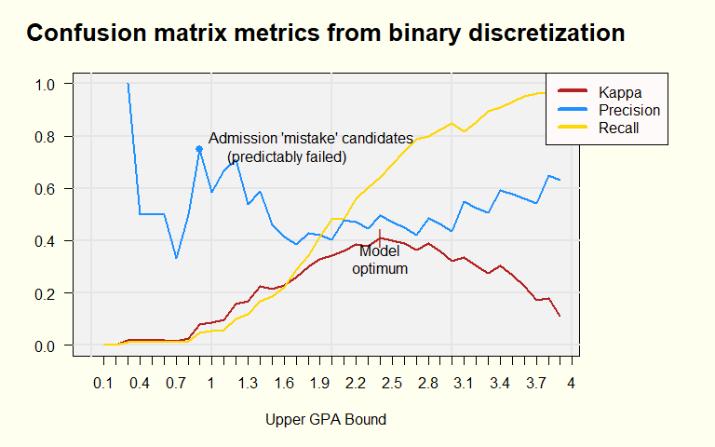
Figure 6: Confusion matrix at model binary optimum
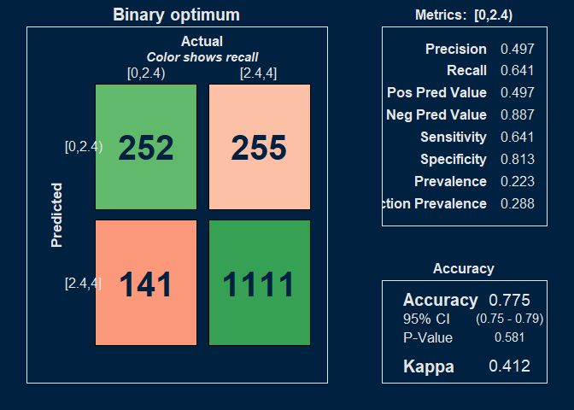
Table 2: Actual failure rates of ‘Success’ and ‘At Risk’ populations at model binary optimum
 | Actual Grade
Predicted Grade | Actual: Fail (<1.7) | Actual: Pass (≥1.7)
[0,2.4] | 147  (8.6%) | 360  (21.2%)
(2.4,4] | 47  (2.8%) | 1148  (67.5%)
Students predicted to have a grade less than 2.4 are a high-risk group of students. 29% of these 507 students actually did fail, or 76% of the total of students who failed. (76% recall and 29% precision).
This compares to the risk of students predicted to have a grade more than 2.4. Only 47 of these 1195 students failed, or 4%.
The following histograms compare the ranges of grades predicted and actually received. In Figure 7, 69 students predicted to get a grade less than 2.4 received a grade of zero. In Figure 8, of the students who actually received a grade less than 2.4, only nine of them were predicted to get a grade less than one.
Figure 7: Illustration of prediction accuracy: where the histogram shows the actual grades received for the grades predicted in the dotted box.
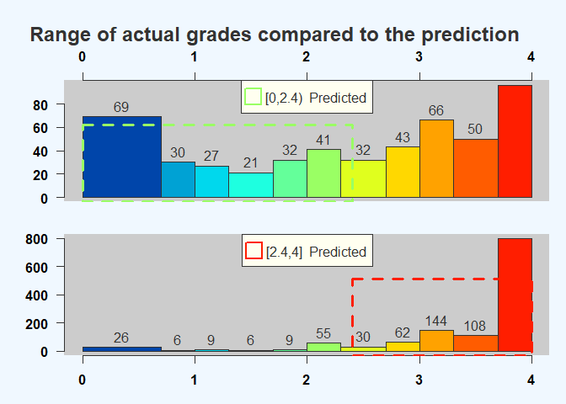
Figure 8: Illustration of prediction accuracy: where the histogram shows the predicted grades for the actual grades received in the dotted box.
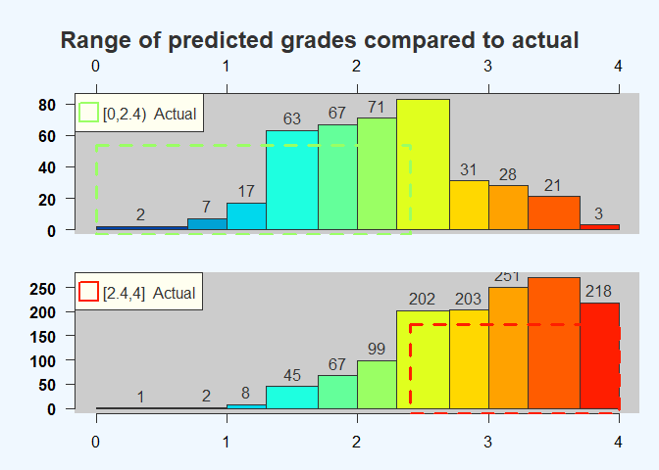
This model also shows a high precision point at a predicted GPA of 0.9. These candidates would predictably fail, and could be considered an admissions mistake. However, there are only eight people so identified (out of 1,759), suggesting nearly all students admitted to the U have a strong expectation of passing initial math courses.
Figure 9: Confusion matrix for ‘admission mistake’ candidates
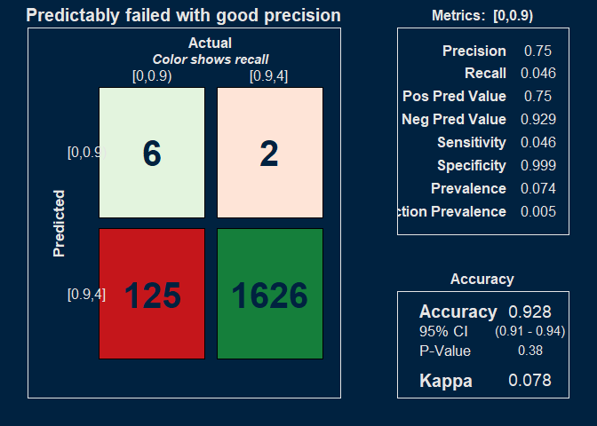

Variable importance
Figure 10: Variable importance to the model
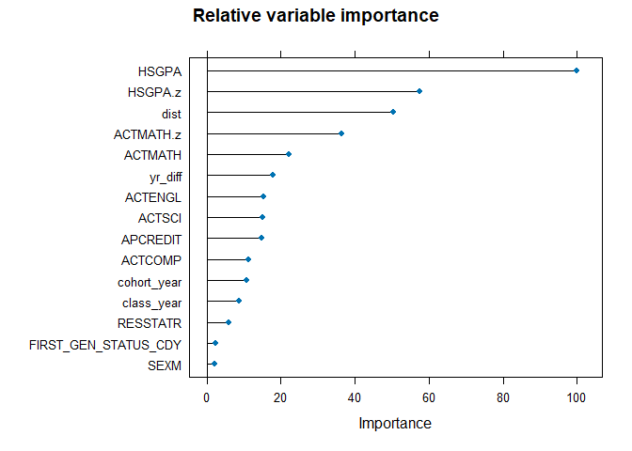
Figure 11: Theory of performance
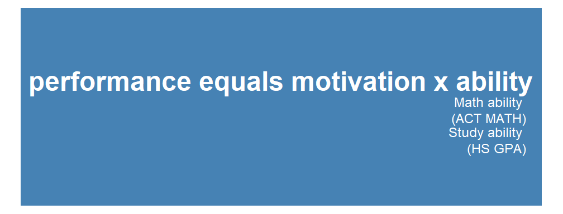
Figure 12: #1 Variable: High school GPA
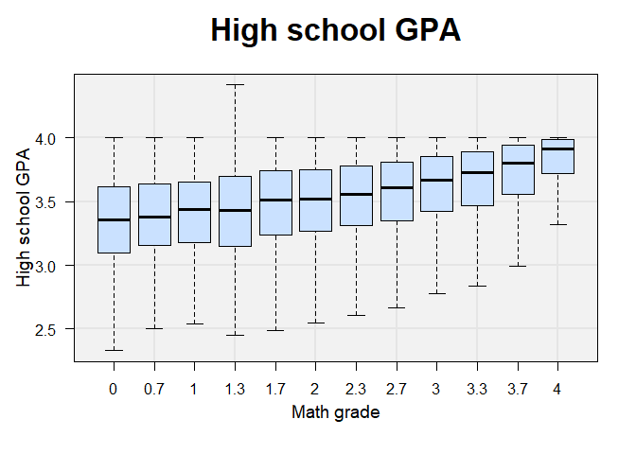
Figure 13: #2 Variable: High school GPA z-score
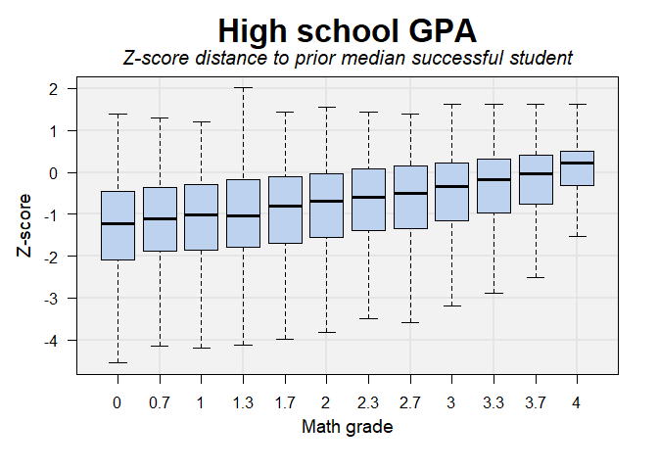
Figure 14: #3 Variable: Combined z-score distance
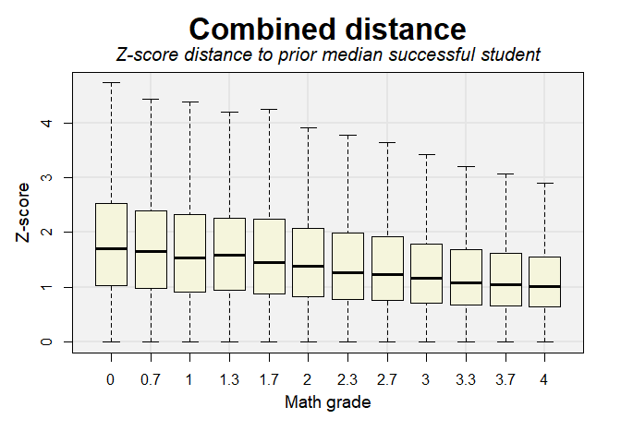
Figure 15: #4 Variable: ACT Math z-score
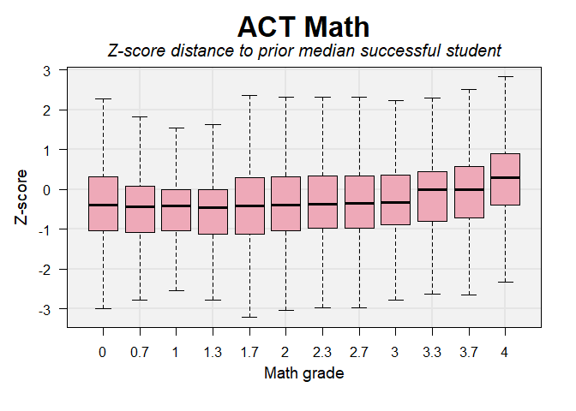
Figure 16: #5 Variable: ACT Math
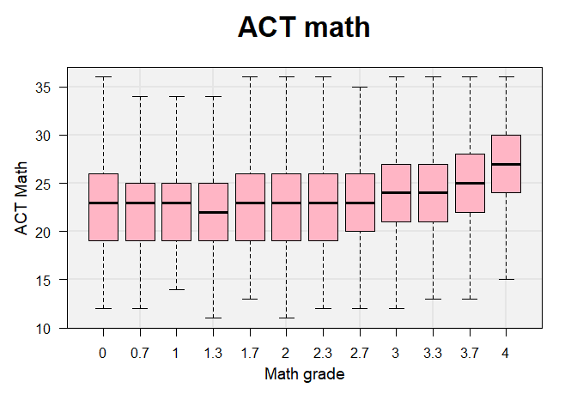
Figure 17: #6 Variable: Years to initial math course
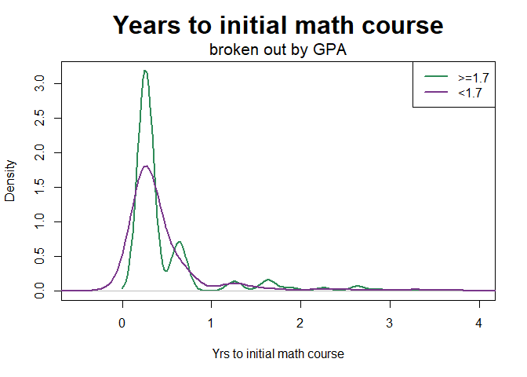
There is a small tendency for people who fail to take the initial math course after the first year. (Most students (89% in 2024) take their initial math course in the first year.)

REFERENCES
Figure 18: How to interpret a confusion matrix
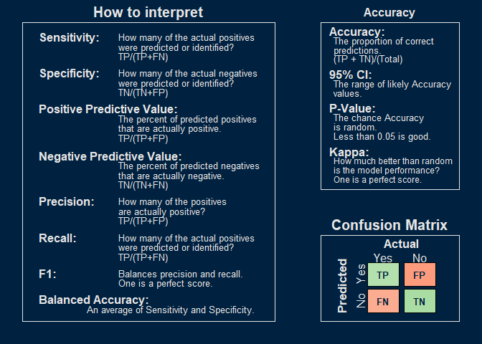

Training data
Data summary
Name | data_list[[“GRADEGPA”]][[…
Number of rows | 36924
Number of columns | 24
_______________________
Column type frequency:
character | 5
factor | 3
numeric | 16
________________________
Group variables | None
Variable type: character
skim_variable | n_missing | complete_rate | min | max | empty | n_unique | whitespace
SEX | 0 | 1 | 1 | 1 | 0 | 2 | 0
FIRST_GEN_STATUS_CD | 0 | 1 | 1 | 1 | 0 | 3 | 0
RESSTAT | 0 | 1 | 1 | 1 | 0 | 2 | 0
HSPRIVATE | 0 | 1 | 1 | 1 | 0 | 2 | 0
season | 0 | 1 | 4 | 6 | 0 | 3 | 0
Variable type: factor
skim_variable | n_missing | complete_rate | ordered | n_unique | top_counts
course | 0 | 1 | FALSE | 25 | MAT: 8834, MAT: 6020, MAT: 4829, MAT: 3293
ETHNICITY | 0 | 1 | FALSE | 9 | C: 26581, H: 4549, A: 2647, M: 1744
age_cut | 0 | 1 | FALSE | 5 | (17: 30141, (18: 3150, (19: 1843, (0,: 1494
Variable type: numeric
skim_variable | n_missing | complete_rate | mean | sd | p0 | p25 | p50 | p75 | p100 | hist
GRADEGPA | 0 | 1 | 2.85 | 1.22 | 0.00 | 2.00 | 3.30 | 4.00 | 4.00 | ▂▁▂▃▇
FA_PELL | 0 | 1 | 0.22 | 0.41 | 0.00 | 0.00 | 0.00 | 0.00 | 1.00 | ▇▁▁▁▂
APCREDIT | 0 | 1 | 7.25 | 12.44 | 0.00 | 0.00 | 0.00 | 12.00 | 85.00 | ▇▁▁▁▁
HSGPA | 0 | 1 | 3.62 | 0.34 | 1.07 | 3.41 | 3.71 | 3.91 | 4.42 | ▁▁▁▇▇
HONORS | 0 | 1 | 0.16 | 0.37 | 0.00 | 0.00 | 0.00 | 0.00 | 1.00 | ▇▁▁▁▂
ACTCOMP | 0 | 1 | 25.05 | 4.33 | 11.00 | 22.00 | 25.00 | 28.00 | 36.00 | ▁▅▇▅▂
ACTENGL | 0 | 1 | 24.84 | 5.28 | 7.00 | 21.00 | 24.00 | 28.00 | 36.00 | ▁▂▇▆▃
ACTMATH | 0 | 1 | 24.44 | 4.59 | 1.00 | 21.00 | 24.00 | 27.00 | 36.00 | ▁▁▅▇▂
ACTSCI | 0 | 1 | 24.95 | 4.55 | 2.00 | 22.00 | 24.00 | 28.00 | 36.00 | ▁▁▅▇▂
cohort_year | 0 | 1 | 2014.59 | 5.08 | 2005.00 | 2010.00 | 2015.00 | 2019.00 | 2023.00 | ▅▆▅▇▆
class_year | 0 | 1 | 2014.96 | 4.99 | 2006.00 | 2011.00 | 2015.00 | 2019.00 | 2023.00 | ▆▆▇▇▇
yr_diff | 0 | 1 | 0.50 | 0.79 | -0.40 | 0.24 | 0.26 | 0.26 | 16.64 | ▇▁▁▁▁
course_level | 0 | 1 | 1.03 | 0.17 | 1.00 | 1.00 | 1.00 | 1.00 | 2.00 | ▇▁▁▁▁
HSGPA.z | 0 | 1 | -0.53 | 1.21 | -42.07 | -1.16 | -0.23 | 0.32 | 2.01 | ▁▁▁▁▇
ACTMATH.z | 0 | 1 | -0.13 | 1.12 | -10.00 | -0.79 | 0.00 | 0.49 | 6.93 | ▁▁▇▅▁
dist | 0 | 1 | 1.41 | 1.01 | 0.00 | 0.72 | 1.18 | 1.86 | 42.07 | ▇▁▁▁▁

Anderson, N. H., & Butzin, C. A. 1974. Performance = motivation X ability: An integration-theoretical analysis. Journal of Personality and Social Psychology, 30(5): 598–604. https://doi.org/10.1037/h0037447

